1. **KPI’s**
2. Total Revenue

SELECT SUM(total_price) AS Total_Revenue FROM pizza_sales;

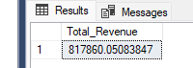

1. Average Order Value

SELECT SUM(total_price)/COUNT(DISTINCT order_id) AS Avg_Order_Value

FROM pizza_sales;

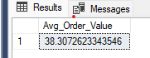

1. Total Pizzas Sold

SELECT SUM(quantity)

FROM pizza_sales;

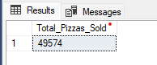

1. Total Orders

SELECT COUNT(DISTINCT order_id) AS Total_Orders

FROM pizza_sales;

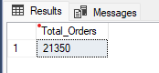

1. Pizzas per Order

SELECT CAST(SUM(quantity) AS DECIMAL)/CAST(COUNT(DISTINCT order_id) AS DECIMAL) AS Pizzas_Per_Order

FROM pizza_sales;

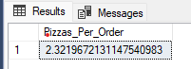

1. **Charts**
2. Daily Trends

SELECT DATENAME(DW, order_date) AS order_day, COUNT(DISTINCT order_id) AS Total_Orders

FROM pizza_sales

GROUP BY DATENAME(DW, order_date);

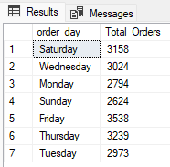

1. Hourly Trends

SELECT DATEPART(HOUR, order_time) AS order_hours, COUNT(DISTINCT order_id) AS Total_Orders

FROM pizza_sales

GROUP BY DATEPART(HOUR, order_time)

ORDER BY DATEPART(HOUR, order_time);

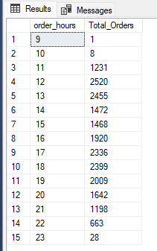

1. Percentage of Sales by Pizza Category

SELECT pizza_category, SUM(total_price) * 100 / (SELECT SUM(total_price) FROM pizza_sales) AS Percentage_of_Total_Sales

FROM pizza_sales

GROUP BY pizza_category;

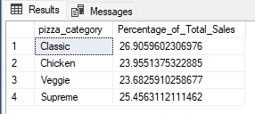

Search by month

SELECT pizza_category, SUM(total_price) * 100 / (SELECT SUM(total_price)

FROM pizza_sales

WHERE MONTH(order_date) = 1)

AS Percentage_of_Total_Sales

FROM pizza_sales

WHERE MONTH(order_date) = 1

GROUP BY pizza_category;

1. Percentage of Sales by Pizza Size

Same as previous query but just change column

SELECT pizza_category, SUM(total_price) * 100 / (SELECT SUM(total_price)

FROM pizza_sales

WHERE MONTH(order_date) = 1)

AS Percentage_of_Total_Sales

FROM pizza_sales

WHERE MONTH(order_date) = 1

GROUP BY pizza_size;

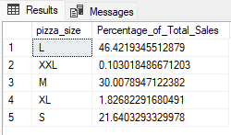

1. Total Pizzas Sold, by Category

SELECT pizza_category, SUM(quantity) AS Pizzas_Sold

FROM pizza_sales

GROUP BY pizza_category;

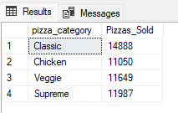

1. Top 5 Best Selling Pizzas

SELECT TOP 5 pizza_name, SUM(quantity) AS Total_Sold

FROM pizza_sales

GROUP BY pizza_name

ORDER BY Total_Sold DESC;

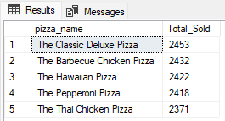

1. Bottom Five Selling Pizzas

Same as top 5, just take out DESC from the ORDER BY

SELECT TOP 5 pizza_name, SUM(quantity) AS Total_Sold

FROM pizza_sales

GROUP BY pizza_name

ORDER BY Total_Sold;

